Title: | Window Lifter  SW Component < XXXXXXX >

History
Issue status  (Index) | Maturity/Date  (draft/invalid/valid)  (dd-mmm-yyyy) | Author  Department | Check/Release  Department | Description
1.0 | Draft  26-Jun-15 | Mario Rivera | Mario Rivera | Creation of the document

Table of Contents
1 Purpose 4
2 Definitions and abbreviations 4
3 Realization constraints and targets 4
4 SW Conceptual design 5
5 SW Component internal breakdown 6
5.1 Functional Decomposition 6
5.2 Function void Task_1ms(void) 7
5.3 Function void Task_10ms(void) 8
5.4 Function void Show_Leds(void) 8
5.5 Function void machine(void) 9
5.6 Function void Set_Direction(void) 10
5.7 Function void Set_Mode(void) 11

Purpose
Window lifter is the module responsible to control the window movement.
Window lifter is controlled by two switches that indicate the direction of the window movement.

Definitions and abbreviations
Definitions
Special Byte | Special byte received to change the baudrate 55h

Abbreviations
Only SW Component specific abbreviations.
References
N° | Document name | Reference
1 | SW Architecture description
 | requerimientos
 | Matriz de trazabilidad

Realization constraints and targets
Automate the car windows to be able to open and close by two buttons. Each button controls a movement. If you push a button(up or down) less than 500 ms, automatic mode will be activated.
In another hand, if you keep pressed the button, manual mode will be activated. Also there's another button that controls anti pinch mode. This button only works when the windows is closing. If you push the button in that moment, anti pinch mode will be activated and get down the windows until it's totally open.
For this purpose the window has to be emulated using a 10 led bar. The color of this led bar has to be RED. The movement of the window has to be simulated turning on/off the LEDS creating the animation of the window movement. The time between each transition shall be 400 msec.
An overview of which are the goals that must be achieved with this functionalities.

SW Conceptual design
For this software there are 'n' function that controls the flow.
- A function to managed each mili second. This function it is use as the most importan task. It means that all the program control will be implement in this task.
- A function that wiil be call each 10 ms. In this function controls that a push button it's true or false. If the button keeps pressed 10 ms then it will be a true button. (True/False button is used to avoid any error in the button as overload)
- A function that will on or off the leds.
- A function that implements a states machine that check if auto, manual, anti pinch or stanby
- A function that indicate the direction(if button open or close is pressed)
- A function that detect what direction is pressed( Open or close)

To make a conceptual design identify the product functions and the programs parts needed to produce them.
- Identifie all relevant parts in a system or sub-system.
- Define which parts are inside & outside the system boundary
- Define de interfaces between these parts, but also interfaces with neighboring systems and environment.

SW Component internal breakdown
For complex SW Components, the designer may define SW Subcomponents. Please consider also the work step "Deal with complexity" provided by the method for Detailed SW Design.
Note: SW Subcomponents are synonymous with the previous used term "Module"
Mapping to the file structure:
- Non complex SW Components should be represented by one object file.
- For complex SW Components each SW Subcomponent should be represented by one object file.
<Subcomponent decomposition if applicable>

Functional Decomposition
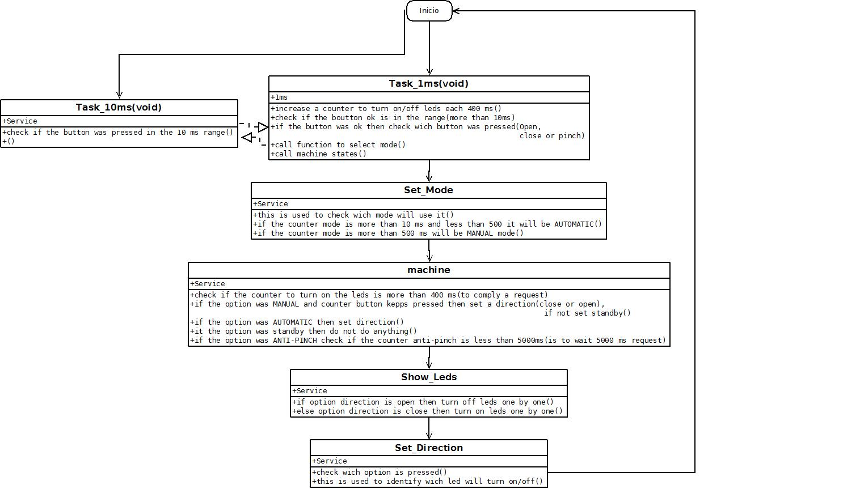
Overview of functions and their dependencies shown by a Static Function Tree
Function Description and Dynamic Behavior
Provide detailed static and dynamic description of all functions of the SW Component.
Functions which are defined in other SW Components shall only be referenced in the external interface description!
The signature description shall be done inside the function header in the source code.
For each function, the following section should be copied

Function void Task_1ms(void)

Description | This function controls all system behavior
Parameter 1 | void
Return Value | void
Precondition | This function is called each 1ms
Post condition | e.g. specific State change e.g. car is locked, EEPROM Values written,  Relation between output parameters where applicable
Error Conditions

Dynamic Behavior
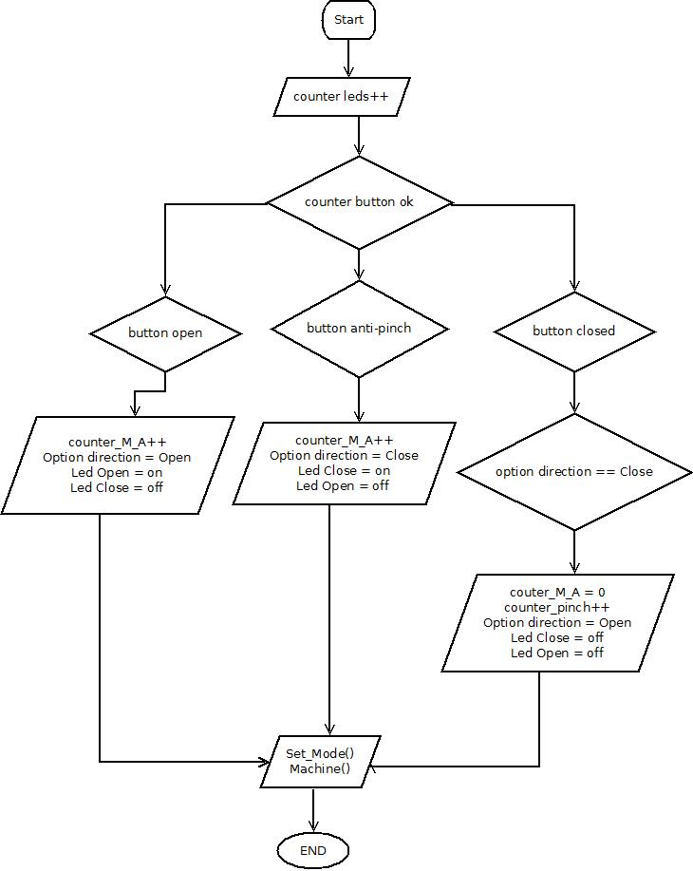

Function void Task_10ms(void)

Description | This function check if any button is pressed in 10 ms
Parameter 1 | void
Return Value | void
Precondition | This function is called each 10ms
Post condition
Error Conditions
Just check if any button keeps pressed 10 ms

Function void Show_Leds(void)

Description | This function turn on/off a indicated led
Parameter 1 | void
Return Value | void
Precondition | This function is called when it has to turn off/on leds
Post condition | e.g. specific State change e.g. car is locked, EEPROM Values written,  Relation between output parameters where applicable
Error Conditions
The program check wich led has to turn off/on the indicated led

Function void machine(void)

Description | This function controls all system behavior
Parameter 1 | void
Parameter 2..n | void
Return Value | void
Precondition | This function is called when detect a new movement
Post condition | e.g. specific State change e.g. car is locked, EEPROM Values written,  Relation between output parameters where applicable
Error Conditions
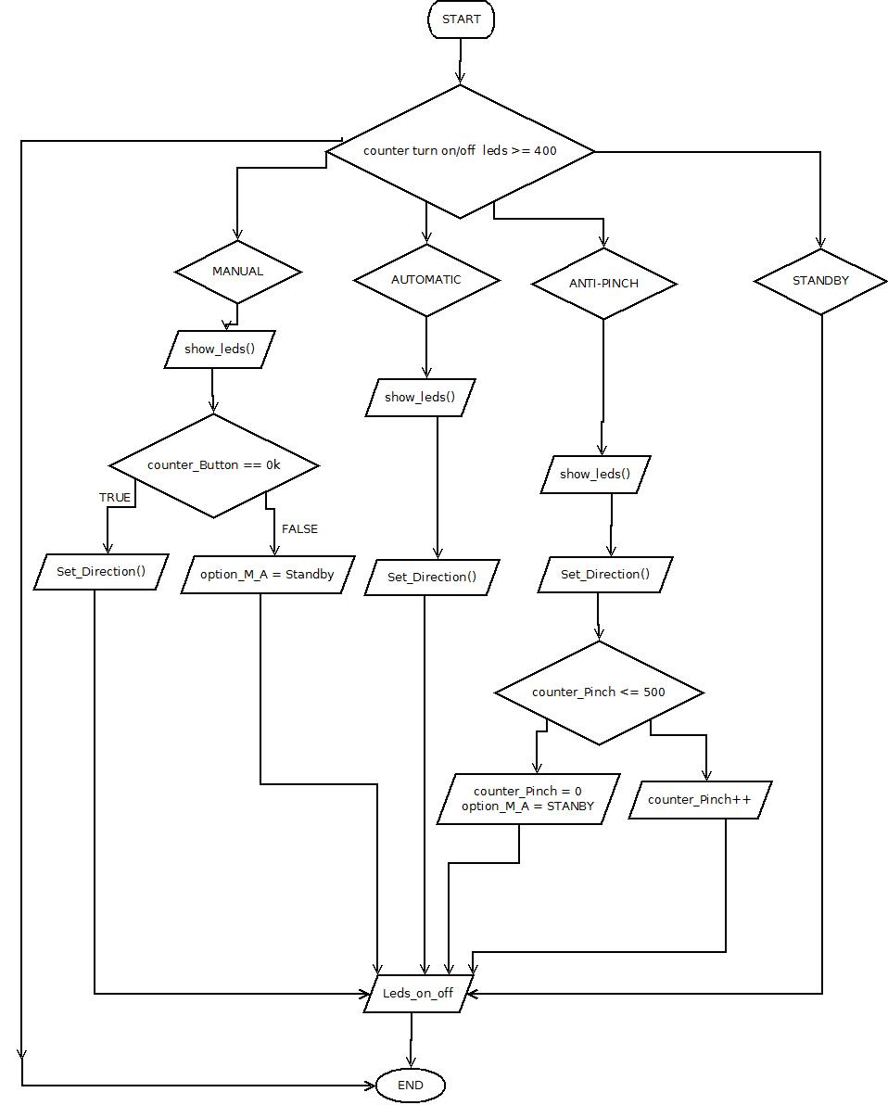

Function void Set_Direction(void)
Description | Chose what is the direction movement and indicate what les has to turn on/off
Parameter 1 | void
Parameter 2..n | void
Return Value | void
Precondition | This function is called when detect a new movement
Post condition | e.g. specific State change e.g. car is locked, EEPROM Values written,  Relation between output parameters where applicable
Error Conditions
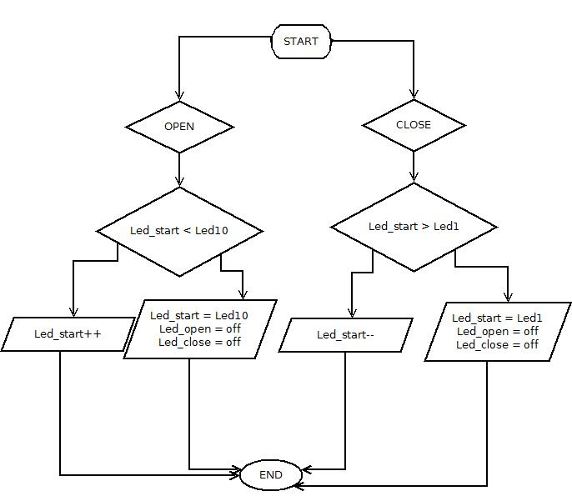

Function void Set_Mode(void)

Description | This function controls all system behavior
Parameter 1 | void
Parameter 2..n | void
Return Value | void
Precondition | This function is called each 1ms
Post condition | e.g. specific State change e.g. car is locked, EEPROM Values written,  Relation between output parameters where applicable
Error Conditions

